**Title Page**

**Project Title:** Recipe Web Page  
**Submitted By:**

* Name: KODANDA RAMA M , Dean joah bell , Thumma Abhijith akshai Reddy
* Roll Number: 2462111 , 2462061 , 2462161
* Email: [m.kodanda@btech.christuniversity.in](mailto:m.kodanda@btech.christuniversity.in) , [dean.joah@btech.christuniversity.in](mailto:dean.joah@btech.christuniversity.in) , thumma.abhijith@btech.christuniversity.in
* **Course:** UI/UX Design Fundamentals  
  **Instructor Name:** Ms.Nagaveena  
  **Institution:** Christ University  
  **Date of Submission:** 13/08/2025

**Abstract**

This project focuses on designing and developing a fully responsive recipe web page using HTML5 and CSS3. The page highlights a specific recipe with detailed steps, ingredients, cooking tips, and attractive food imagery. The main objective is to deliver a visually engaging layout that is easy to read and navigate across devices. The design emphasizes clarity, accessibility, and a mobile-first approach, ensuring a pleasant experience for cooking enthusiasts.

**Objectives**

* Create a clean, visually appealing recipe page layout.
* Use HTML5 semantic tags for structured presentation of ingredients, steps, and images.
* Apply CSS styling to enhance readability and user engagement.
* Ensure responsiveness across desktop, tablet, and mobile devices.
* Maintain fast loading times and optimal image usage.

**Scope of the Project**

* Front-end design only; no server-side functionality.
* Supports recipe content for one featured dish.
* Includes sections for Recipe Title, Hero Image, Ingredients, Cooking Instructions, and Tips.
* No use of frameworks or external CSS libraries; pure HTML and CSS.

| **Tool/Technology** | **Purpose** |
| --- | --- |
| HTML5 | Markup structure for recipe content |
| CSS3 | Styling, colors, and responsiveness |
| VS Code | Code editing |
| Chrome DevTools | Testing and debugging |

**HTML Structure Overview**

* **Header:** Recipe title and navigation links (e.g., Home, Recipes, Contact).
* **Hero Section:** Full-width image of the dish.
* **Ingredients Section:** Unordered list of all required ingredients.
* **Instructions Section:** Numbered list of cooking steps.
* **Tips Section:** Extra suggestions or variations.
* **Footer:** Copyright and social links.

**CSS Styling Strategy**

* External stylesheet with sections for layout, typography, and responsive design.
* Flexbox and CSS Grid for arranging content.
* Media queries for tablet and mobile adaptations.
* High-contrast colors and clean fonts for readability.
* Hover effects for navigation and ingredient highlighting.

**Key Features**

| **Feature** | **Description** |
| --- | --- |
| Responsive Layout | Adapts to all screen sizes seamlessly |
| Hero Image | High-quality image to attract attention |
| Ingredient List | Clear bullet-point format |
| Step-by-Step Instructions | Sequential, easy-to-follow layout |
| Cooking Tips | Extra information for better results |

**Challenges Faced & Solutions**

| **Challenge** | **Solution** |
| --- | --- |
| Image distortion on small screens | Used max-width: 100% and object-fit: cover |
| Text readability on image backgrounds | Applied semi-transparent overlay and adjusted font color |
| Long step list alignment | Used CSS Grid to split instructions into columns on larger screens |

**Outcome**

* Delivered a user-friendly and visually appealing recipe page.
* Achieved full responsiveness without external libraries.
* Improved understanding of semantic HTML and CSS layout techniques.

**Future Enhancements**

* Add JavaScript for recipe timers and ingredient checklists.
* Include video tutorials for each step.
* Implement recipe search and filtering features.
* Add user rating and comment sections.

**Sample Code**

* {

    margin: 0;

    padding: 0;

    box-sizing: border-box;

}

html {

    scroll-behavior: smooth;

}

body {

    font-family: 'Segoe UI', sans-serif;

    line-height: 1.6;

    background: linear-gradient(to bottom right, #fffaf5, #ffecec);

    color: #333;

}

**Screenshots of Final Output**

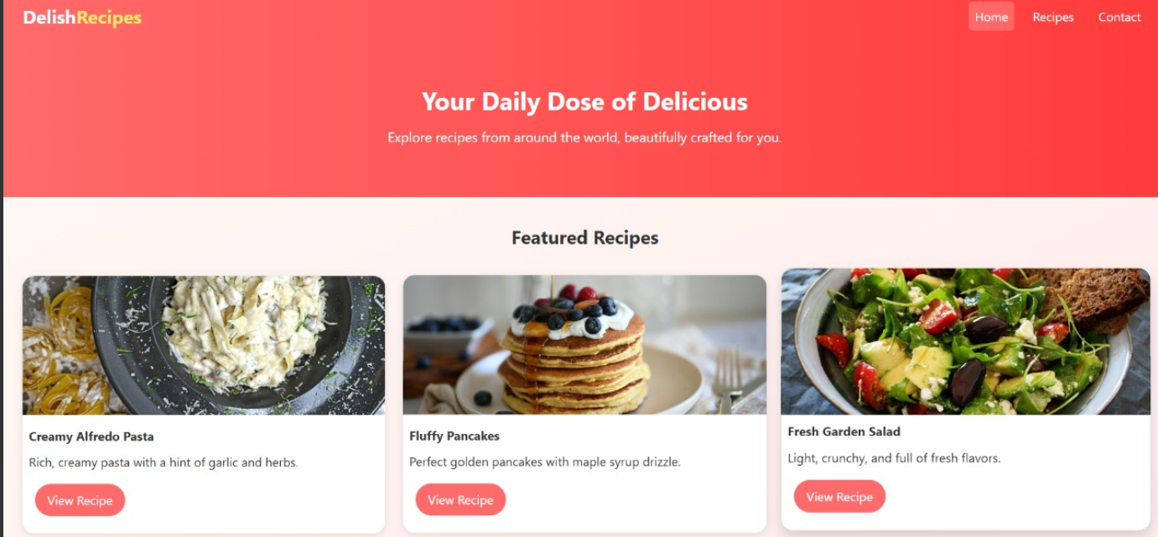

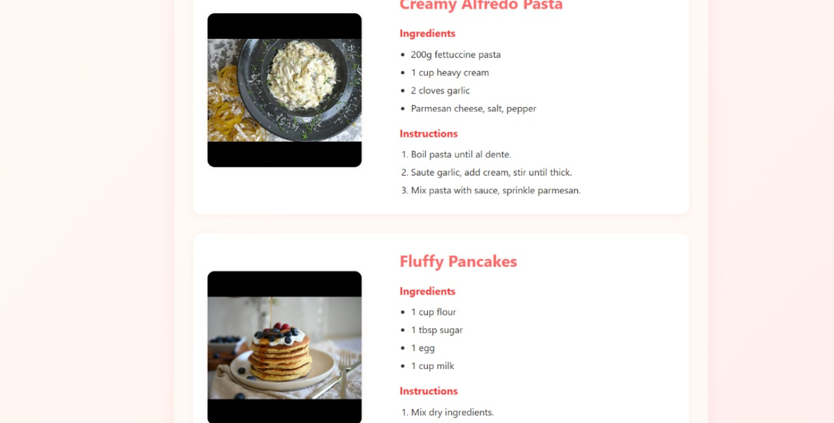

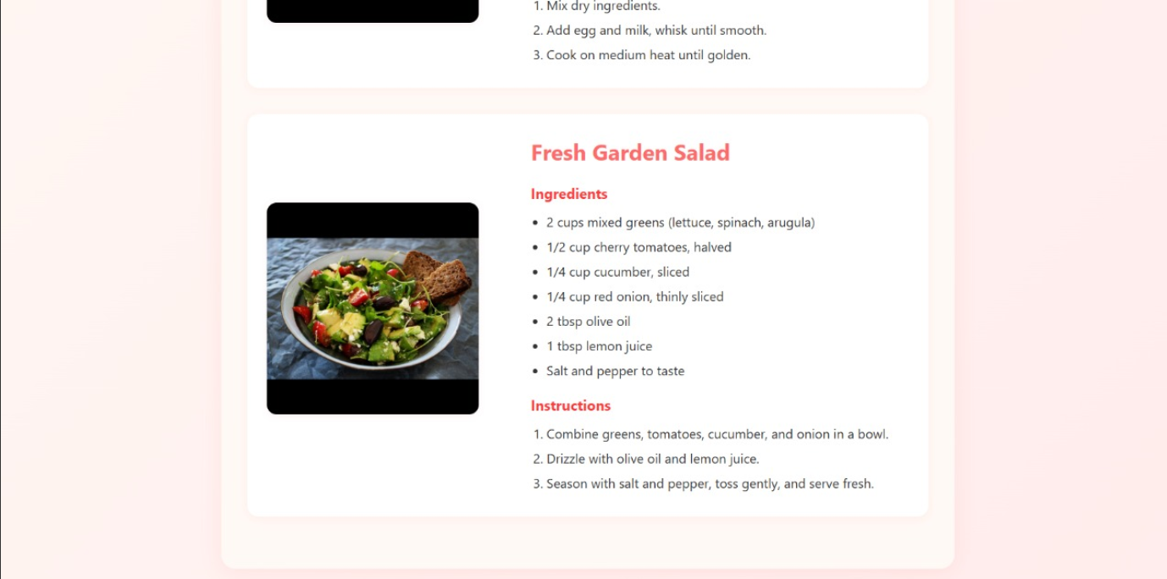

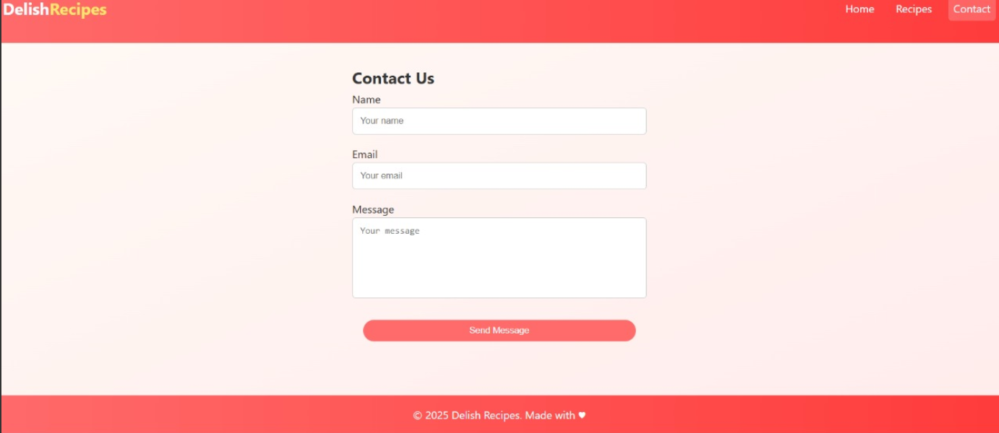

**Conclusion**

This recipe page project strengthened my skills in responsive web design, typography, and layout structuring. I learned how to present content in a user-centric way that balances visual appeal and functional readability. The project also improved my ability to work with semantic HTML for structured data representation.

**References**

* L&T LMS: <https://learn.lntedutech.com/Landing/MyCourse>